Republic Polytechnic

**A107 Physics**

**Problem Review Part 1 (P1-P4) – Practice Questions**

1. Convert the following:

1. 2.5 feet = _______________ yard
2. 100 km/h = ________________ m/s
3. 5 mm = _______________ × 10−3 m

2. Given that

|  |
| --- |
| 1 metre = 3.281 feet  1 yard = 3 feet |

Convert 2.5 yards to metres.

3. An equation is proposed as shown:



where *E* is energy, *m* is the mass and *v* is the velocity.

By comparing the SI base units on both sides of the equation, explain if the proposed equation is valid or not?

4. Determine the magnitude and direction of the net (i.e. overall) force acting on the object shown in Figure 1.

10 N

7 N

5 N

7 N

Figure 1

5. Figure 2 shows three forces acting on an object.

*F*1 = 400 N

35°

60°

*F*2 = 500 N

*F*3 = 800 N

Figure 2

1. Determine the net horizontal force acting on the object.
2. Determine the net vertical force acting on the object.
3. Determine the magnitude of the net force acting on the object.
4. A car is initially at rest. It then accelerates with an acceleration of 12 m/s2 for 4 s.
5. What is the velocity of the car at the end of the 4 s?
6. What is the total distance travelled by the car?
7. A car is initially moving with a velocity of 10 m/s. It then accelerates with an acceleration of 8 m/s2 for 6 s.
8. What is the final velocity of the car at the end of the 6 s?
9. What is the total distance travelled by the car in this 6 s?
10. Figure 3 shows the velocity-time graph of a car.

10

20

4

Time (s)

Velocity (m/s)

0

2

Figure 3

1. Determine the magnitude of the acceleration of the car from time *t* = 0 s to *t* = 2 s.
2. What is the total distance travelled by the car during the 4 s?
3. The velocity-time graph of a car is depicted in Figure 4.

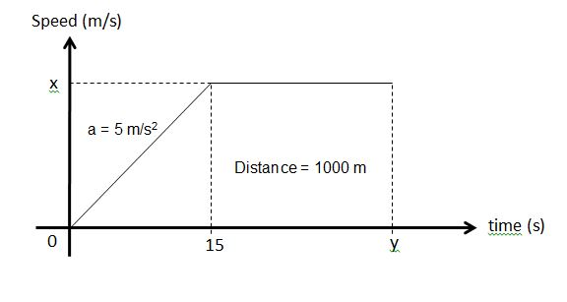

Time (s)

*y*

*x*

500 m

Velocity (m/s)

Figure 4

Given that the car accelerates at 5 m/s2 from time *t* = 0 s to *t* = 15 s, and travels 500 m from time *t* = 15 s to *t* = *y* s,

a) Calculate the value of *x*.

b) Calculate the value of *y*.

1. Figure 5 shows a constant force of 50 N exerted horizontally on a 2 kg object. The object moves with a constant velocity.

*v*

50 N

2 kg

Figure 5

What is the magnitude of the acceleration of the object? Explain your answer.

1. Figure 6 shows four forces acting on a 4 kg object.

3 m/s2

30 N

60 N

4 kg

*F*1

*F*2

Figure 6

Given that the magnitude of *F*1 is two times that of *F*2 and the acceleration of the object is 3 m/s2 to the right as shown in Figure 6,

1. Determine the magnitude of the net force acting on the object.
2. Determine the magnitude of *F*1 and *F*2.
3. Figure 7 shows 8 kg object sliding down a slope inclined at 20°. Take *g* = 10 m/s2.

8 kg

20°

Figure 7

1. Determine the magnitude of the net force that is acting on the object in the direction of motion as shown assuming that the slope is frictionless.
2. Determine the magnitude of the acceleration of the object in the direction of the motion assuming that the slope is frictionless.
3. Determine the magnitude of the normal reaction force acting on the object from the slope.
4. If the 8 kg object is replaced with a 16 kg object, would the magnitude of the acceleration in the direction of the motion be doubled?
5. If there is a frictional force of 20 N along the slope, determine the magnitude of the net force that is acting on the 8 kg object.

13. Find the magnitude of the acceleration of a 5 kg stationary object resting on a table when subjected to an applied force of 50 N as shown in Figure 8. You may assume that friction is negligible.

50 N

5 kg

Figure 8

1. A non-uniform wooden plank of length 200 cm is hung using two strings attached to both ends. Figure 9 shows the free-body diagram of the plank, in which *F*1 and *F*2 is the tension in the string at each end respectively and *W* is the weight of the plank. The magnitude of *F*1 is 45 N and *W* could be considered to be acting at a point which is 30 cm away from the thicker end of the plank. The plank is in static equilibrium.

**200 cm**

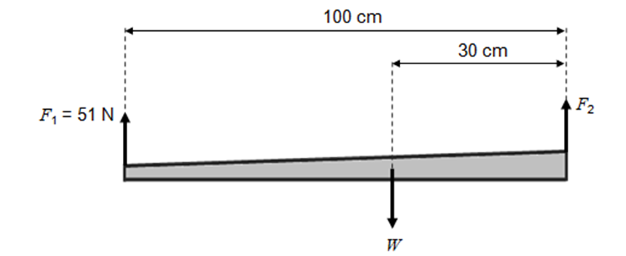

**45 N**

Figure 9

1. Determine the magnitude of *W*.
2. Determine the magnitude of *F*2.
3. By taking *g* = 10 m/s2, determine the magnitude of the force *F* depicted in Figure 10.

5 kg

*F*

0.6 m

0.4 m

Figure 10

1. By taking *g* = 10 m/s2, determine the magnitude of the force *F* depicted in Figure 11.

*F*

2 m

10 m

2 m

4 m

4 kg

7 kg

20 kg

Figure 11

1. Determine the tension *T* for the scenario depicted in Figure 12.

50 N

*T*

0.2 m

0.8 m

Figure 12

**<< THE END >>**